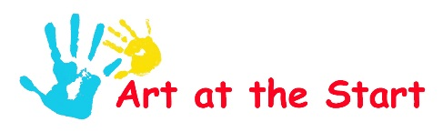
Some contemporary art with 3-d slotted sculptures
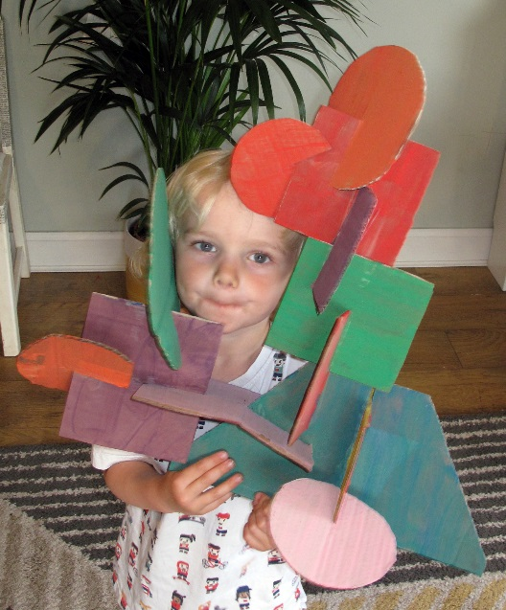
If you are trying to find lots of craft possibilities from your recycling bin to keep small children entertained at home then this is a good one to try. It’s like the construction toys you may have had as a kid only taken much bigger. It’s nice because you paint it flat so it’s easy for very wee ones to paint but can join together to make something special. And children can play at making different sculptures from the same pieces so it may hold attention a bit longer than other craft projects.
You need:
• Thick cardboard, like a delivery box from your recycling
• Paints and brushes
• Covered table or floor
• Scissors
You need to start by cutting out lots of different shapes from the cardboard. For babies you can do this yourself in advance but toddlers can join in by helping to draw round plates and bowls to get circles. It doesn’t matter if they shapes are wonky, so if toddlers want to draw them for you to cut out then that will be fine. Older children can do the shapes and the cutting. Once you have a good selection of shapes you need to cut a slot half way up each one. If the card is thick, do two cuts

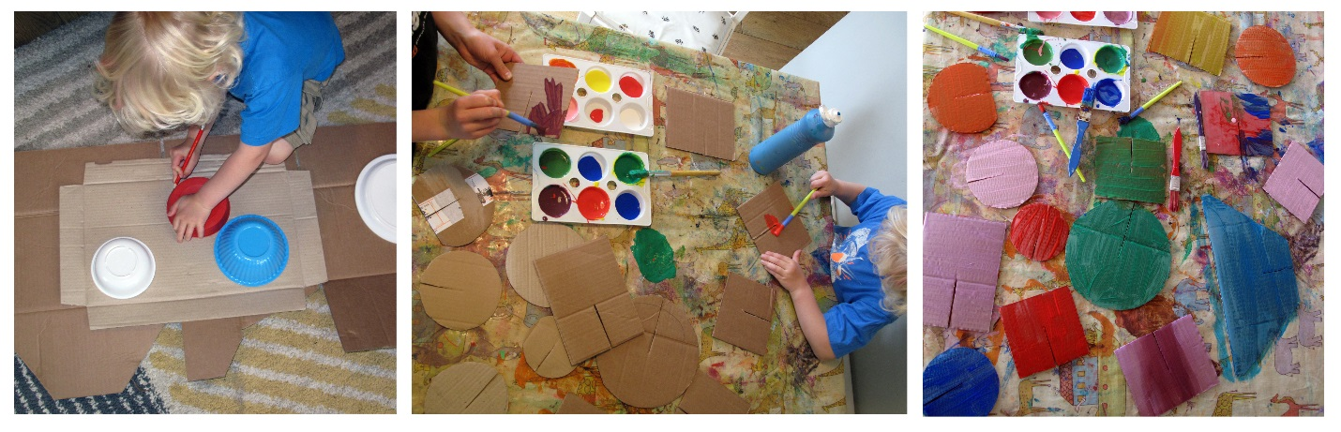
beside each other to make the slot bigger (this bit probably needs to be done by the adult)

Now you can let wee ones decorate all their shapes with the paints, as brightly coloured as possible. If they have the patience to let them dry and then flip to do the backs too, even better. Once they have dry they can then slot the pieces together. Let wee ones try whatever they fancy to build a sculpture worthy of being in a modern art gallery!
