

Rhododendron collection at Dundee

To those of you who are not familiar with the layout, Dundee Botanic Garden has a linear route through the gardens length, so a walk of half an hour is required to reach the eastern end of the garden, and this is where you will find the Rhododendrons of the Far East!



The visitor may travel through five different phytogeographic areas along the way so not everyone discovers this furthest corner of the garden. Let us explore this ‘off the beaten track’ area!

Although this area of the garden has often been described as Asia, in fact most of the Rhododendrons are from China or Bhutan. Some of the earliest, most cherished specimens are to be found here with plantings dating back to 1977, such as the tree Rhododendron, *R. arboreum* which is one of the earliest to flower. The first garden Curator, Eddie Kemp had strong links with Royal Botanic Garden Edinburgh and introduced many quality plants from there during his tenure.

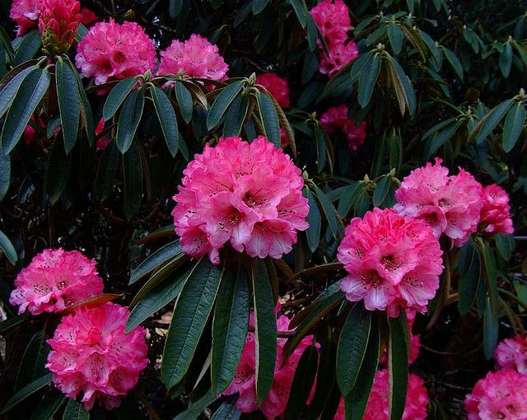

Figure 1: Rhododendron arboreum at Dundee Botanic garden

In keeping with the tradition of Rhododendron culture this area was intended to have an informal woodland layout with a few, well-spaced trees for shade and shelter. The collection took a great step forward when new plants were acquired from the garden of George Sherriff.

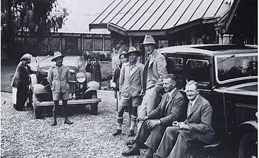Major George Sherriff spent many years collecting seeds and plants in Asia with his colleague, Frank Ludlow. Plants introduced by this team can be found in gardens throughout the UK. When Sherriff retired from his travels he chose to settle in Kirriemuir where he created a garden full of his treasures.

Figure 2: Frank Ludlow, standing [with characteristic hat], Major George Sherriff, and Frederick Williamson, and local colleagues in Gangtok, Sikkim, c 1933. Sherriff was a Scottish explorer and plant collector whose private collection form the basis of Dundee Botanic Garden Rhododendron collection. (Source: Williamson Collection, Cambridge University Museum of Archaeology and Anthropology)

When this property changed hands in the 1980’ s the contents of the garden at Ascreavie, Kirriemuir, were offered for sale and the new botanic garden at Dundee was able to purchase some beautiful well grown plants. One example is *R. erosum,* a plant about 2m high now which often flowers in March with deep red blooms.

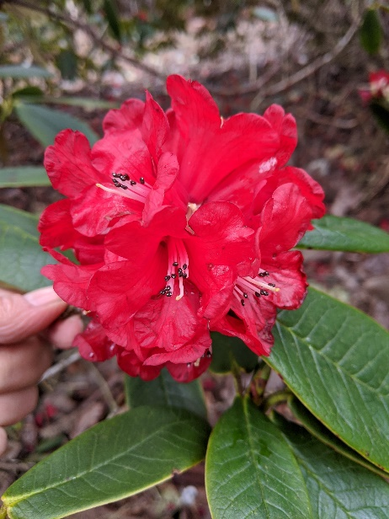Most of the famous plant collectors like George Sherriff were known for their meticulous record keeping which included the habitat, altitude and climate as well as the geographic location.

Figure 3: Rhododendron erosum introduced by Sherriff in 1936 to garden cultivation in the west

This crucial knowledge helps us to grow the plants but is also of importance for conservation ; details of wild provenance plants from botanic collections inform the global conservation strategies of today – but that’s another story.

We know the seeds of *R.erosum* were collected in 1936 from plants growing on the northerly slopes of the mountains at 3000 m with high rainfall. A native of the eastern Himalaya, found by Ludlow and Sherriff in 1936 on the Tibetan side of the range (Chayul and Tsari) at 10,000 to 12,000 ft, and introduced by them.

Rhododendron grown from seed can be slow, some plants take 10 or 15 years to reach flowering size. As precipitation in Dundee is significantly lower than in the native habitat, this results in slow growth of all the Rhododendrons. Slow growth seems to be a good strategy for ageing well, as our inherited *R. erosum* is now over eighty years old and still growing well, making it one of the oldest plants in the garden. We hope this continues for some time to come as we know from colleagues in the West Coast that some of their gardens Rhododendron collections from the 1920’s are still flourishing.

Further valuable additions arrived in 1992 from a collecting expedition in Yunnan undertaken by colleagues at the Royal Botanic Gardens Edinburgh which they shared to help conserve the genetic diversity of the species in cultivation by spreading risk with other institutions. More recently a dozen rare species were planted which originated from collections by Ray Cox of Glendoick Nursery have been acquired to extend and enrich the collections with introductions with the plants introduced by Scottish plants people.

In recent years there have been very dry spring seasons which allows our visitors a glorious opportunity to view the blossom – but dry seasons have a serious impact on our plants. Over time a combination of leaf mould and bark chip has formed a beneficial mulch which helps to protect the root zones but supplementary watering is also needed, particularly in late summer and autumn when flower buds are formed for the following spring. The garden staff keep a watchful eye for the various pest and diseases likely to affect mature and slightly 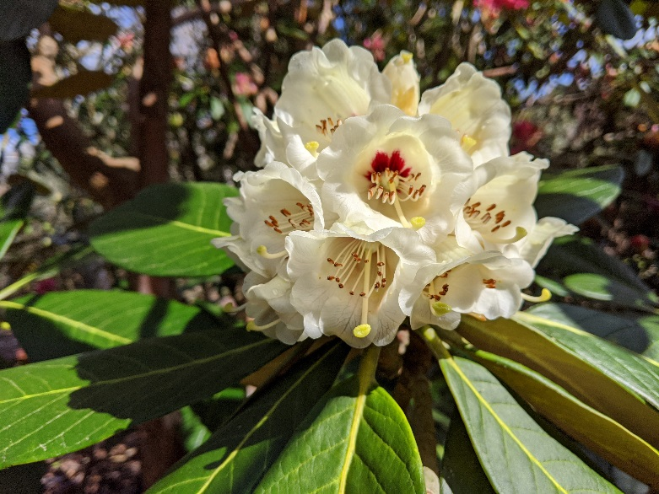stressed Rhododendrons.

Figure 4: Rhododendron macabeanum in the garden showing its flower trusses, of bell-shaped, pale to deep yellow , with a purple basal blotch. The leaves can extend up to 30cm (12 inches) long and have a felted (indumentum) buff coloured underside which is a distinguishing feature of this species.

In common with the whole garden there is a continuing need for shelterbelt trees to act as protection from the prevailing south westerly winds, in particular the large leaved Rhododendron species suffer from wind damage. Some of the conifers from the 1970 s have had to be removed and we are replanting the gaps with smaller, deciduous trees to take place and improve the protection of this shelter belt.

A plant collection continually evolves and our records need to be as meticulous as George Sherriff’s in 1936. To support this the garden database is updated regularly and occasionally expert verification is sought from external specialists to ensure we are being as accurate as possible. The networks we have established and maintained over the years through the botanic garden community enable us to assess the information on rarity status and adds to the conservation value of each plant we grow. A pressing issue as we see the loss of many of the landscapes where these plants were collected, due to the modern pressures of globalised development driven by natural resource extraction and use. Since the days of Ludlow and Sherriff the abundance of many of these plants is much reduced.

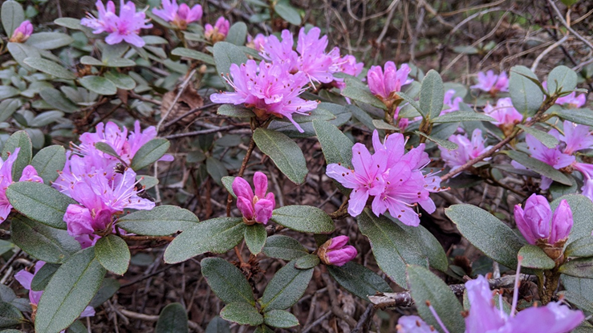Although the collections area given to Rhododendrons is fairly modest, in this relatively hidden area of the garden there are over a hundred different Rhododendron species to be found and enjoyed. There are more than sixty being of known wild provenance, from regions as diverse as Japan, Korea, Bhutan and Nepal that are of the highest conservation value nationally and internationally. In sharing this insight to a lesser visited area of the garden we hope you feel inspired to visit this spring and enjoy the many shapes and colours to be found here.

Figure 5: Rhododendron cuneatum, listed as Vulnerable by IUCN. (International Union for Conservation of Nature).Now found only in a few location in south west Sichuan. Fortunately an easy plant to propagate.

**Plants to look out for :**

Early season from March : *R.leucaspsis, R. arboreum, R. calophytum,*

April and May : *R. augustinii , R. wallichii*

Late into June : *R.rubiginosum R. weyrichii*

Anytime : striking foliage , turn the leaves over and admire

Clare Reaney

Botanical Horticulturalist

10/02/2020