Content Creation Steppingstones

A simple guide to aid the design of content and media for education

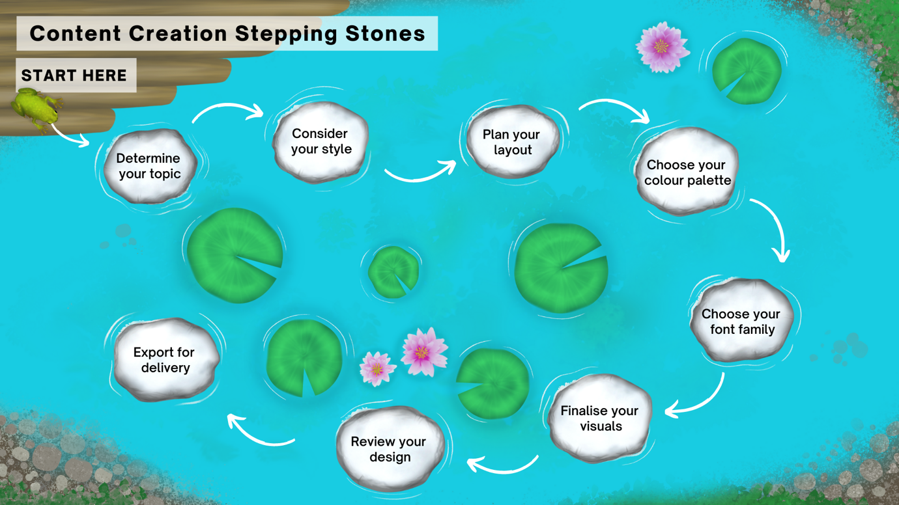

- Determine your topic
  - Can you split your topic into smaller chunks?
- Consider your style
  - Is your style consistent?
- Plan your layout
  - Does it flow well?
- Choose your colour palette
  - Are your colours accessible?
- Choose your font family
  - Is your text easy to read?
- Finalise your visuals
  - Can you use existing content?
- Review your design
  - Have you peer reviewed?
- Export for delivery

